BACS2163 Software Engineering – Assignment
1. Objectives
This assignment provides students with the opportunity to learn and apply the following skills;
∙ Ability to work as a team to produce a project planning schedule with the use of planning tool like MS. Project and to produce system requirements specification + viewpoint hierarchy.
∙ Application of various tools and development methodologies, including the production of various analysis and design documentation in the process of system development and good screen design principles to design quality user interfaces.
2. Assessment
The learning outcomes assessed are:
CLO 2: Analyse the use and importance of different methods, tools and techniques to software design, development, testing and maintenance, and different process models of software development. (C4, PLO2)
CLO 3: Produce a report based on a project scenario. (C3, PLO6)
Contribution of marks to coursework:
∙
Parts | Marks
Assignment report - Part 1 | 25
Assignment report - Part 2 | 25
Assignment report - Part 3 | 30
Assignment presentation | 20
Total | 100

* Note: Tutor has the right to adjust the marks based on the % contribution by each team member. ∙
3. Group Formation
- Students will be assigned to groups of (4 )members per team from the same tutorial group by the tutor.
- Students are required to answer the given assignment topic.
- Every team member is expected to contribute and participate actively in the entire process of completing the assignment to develop documentation such as project planning schedule, system requirements, viewpoint hierarchy, architectural design, test plan, and to apply good user interface design principles when designing the user interface. Sharing of ideas and assistance in the completion of assignment among members is required.
4. Assignment Tasks for Part 1, 2, and 3
The usage of mobile apps or system has experienced exponential growth due to several factors. Firstly, mobile devices have become more affordable, powerful, and accessible, allowing a larger population to own smartphones and tablets. The widespread availability of high-speed internet and the development of app stores have also contributed to the popularity of mobile apps. Mobile apps are utilized across various domains and serve diverse purposes. Thus, you are required to choose ANYONE (1) from the below domains for your assignment.

- Online Food Ordering System:
Develop a platform for customers to browse menus, place orders, and track delivery status. Include features like user registration, menu management, order management, and delivery tracking.
- E-commerce Application:
Create an e-commerce website where users can browse products, add them to a shopping cart, and make online payments. Implement features like product search, user authentication, shopping cart management, and payment integration.
- Task Management Application:
Design a task management application that allows users to create, assign, and track tasks. Include features like task creation, assignment, priority setting, status tracking, and deadline reminders.
- Library Management System:
Build a software system to manage library operations such as book lending, returning, and inventory management. Implement features like book cataloging, member registration, borrowing history, and fine calculation.
- Student Information System:
Develop a system to manage student records, including registration, course enrollment, and grading. Include features like student registration, course management, grade calculation, and progress tracking.
- Ticket Booking System:
Create a ticket booking system for events, movies, or transportation. Implement features like seat selection, ticket reservation, payment processing, and ticket confirmation.

Part 1

- Organisation background. Introduction of selected organisation [ 5 marks]
- Requirement gathering techniques + Problems of existing system. Apply and discuss TWO (2) relevant fact-gathering techniques to analyse the problems of existing system. Identify FIVE (5) the major problems of the existing system. [5 + 5 marks]
- Software quality attributes of the project. Suggest and explain FIVE (5) critical software quality attributes for the new proposed system. Justify your suggestion. You may make any relevant assumptions to support your answer. [5 marks]
- Software process model. Recommend ONE (1) appropriate process model for this project. Explain the suggested model and justification of suggestion. You may make relevant assumptions to support your suggestion. [5 marks]

Part 2
- Project planning schedule. Prepare Task Allocation List & Gantt Chart for this project. (Should make use of Microsoft Project Planning software). [10 marks]
- System requirements. Compose Functional Requirements for each module and Non-Functional Requirements (Product, Organisation, and External requirements) of the proposed system. [10 marks]
- Viewpoint-oriented analysis. Carry out a viewpoint-oriented analysis to identify all necessary viewpoints involved in the proposed system and justify the roles/importance of such viewpoints involved. [5 marks]
Part 3
- An architectural design. Recommend and design ONE (1) suitable System Organization Model. Explain the suggested model and justification of suggestion. You may make relevant assumptions to support your suggestion. [5 marks]
- Test planning and Test Cases. Prepare a Test Plan which covers Testing Process, Tested Items, Testing Procedure, Testing Requirement, and Testing Constraints for the proposed system. Prepare Test Cases based on the functional requirements identified. [15 marks]
- User interface design principles. Suggest and explain design principles that will be applied to design the user interface of the proposed system. Justify your suggestion with the relevant prototype. This could be done in any of the language you are familiar (E.g. Java, HTML). [10 marks]

5. Assignment Schedule
Week | Practical Task | Deliverable
1 | Briefing on practical assignment  Organization background | Week 2’s task(s)
2 | Requirement gathering techniques + Problems of existing/legacy system | Week 3’s task(s)
3 | Software quality attributes | Week 4’s task(s)
4 | Software process model | Week 6’s task(s)
5 | Software process model | Week 6’s task(s)
6 | System Requirements (Functional and Non-Functional requirements) | Week 8’s task(s)
7 | System Requirements (Functional and Non-Functional requirements) | Week 8’s task(s)
8 | System Architectural Design (System Organisation Model) | Week 9’s task(s)
9 | Test Plan and Test Cases | Week 10’s task(s)
10 | User interface design principles + Prototype | Week 11’s task(s)
11 | Assignment Feedbacks  Make-good (if any) | Presentation  Softcopy/Softcopy  Assignment Report

6. Oral Presentation
Each student is required to present the assignment tasks (part 1, 2 and 3) as specified and submit accordingly. Oral presentation MUST include visual aids.
The final assignment report for all Parts should contain the following items:
(a) Cover sheet (Appendix - FORM 1)
(b) Plagiarism statement with student signatures (Appendix - FORM 2)
(c) Assessment Criteria (Group and Individual)
(d) Table of Contents
(e) Contents for Part 1, 2, and 3
(f) Reference section (Students are required to use APA Referencing System format) (g) Appendices (if any)

The report must be type-written using MS-Word. You are recommended to format your report according to the following specification:
Media  Font Size | Softcopy - well written and properly formatted report (Part 1, Part 2 and Part 3) to be submitted via Google Classroom which include all work/deliverables for assignment report and recorded individual presentation for assignment presentation as mentioned above.
Media  Font Size | A body text of font size 12 is required while for headings and subheadings a larger font size must be used.
Font Style | Use Times New Roman for body text. Main headings and sub-headings should be clearly stated using suitable font styles (e.g. Arial).
Line Spacing | Typed material should be 1.5-line spaced.
Alignment | Use Justify for alignment.
Headers and Footers | Appropriate footers and headers should be used to enhance clarity and presentation.
Page Numbering | Ensure that all pages (except cover page) are numbered.
Paper Size | Use A4 paper (29.7cm x 21cm).

Table 1: Written Report Format
8. Late Submission
All assignments should be submitted by the stated due date as Section 5.
Late submission of the assignment will be handled according to the Guideline for Late Submission of Coursework available at TAR UMT’s Intranet🡪Examinations and Credit Accumulation🡪Undergraduate🡪 Guideline.
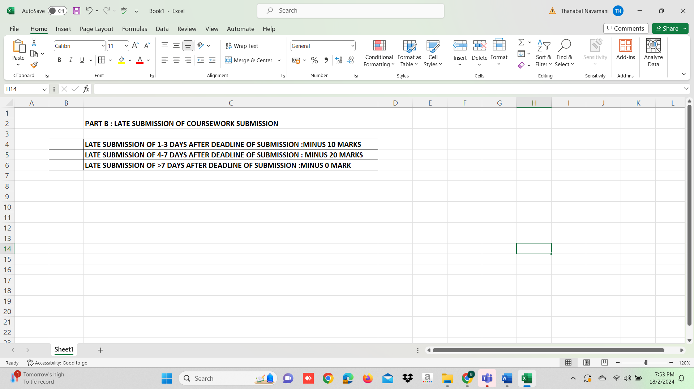
In certain circumstances, a student may be allowed to submit the assignment late with valid reason. S/he must inform the respective tutor at least one week before the assignment is due. The tutor will evaluate whether the circumstance warrants submitting the assignment late, but no guarantee that the students will not be penalized. As a general rule, no extension of time will be granted. The assignment question and its due dates are normally disclosed in advance to students in order that they will be able to manage their time according to different course study progress and complete this assignment on time.

9. Academic Integrity and Plagiarism
Students are required to redo the entire assignment depending on the seriousness of inaccuracy of the answer or if the contents of any part of the assignment does not comply with the requirements of the assignment as requested by the respective lecturer/tutor.
Before submitting your assignment, please make sure that you have complied with TARUMT Plagiarism Policy. Any cheating, attempt to cheat, plagiarism, collusion and any other attempts to gain an unfair advantage in assessment will cause the students concerned to be penalized.
IMPORTANT: Students found to be dishonest are liable to disciplinary action.

Appendix
FORM 1
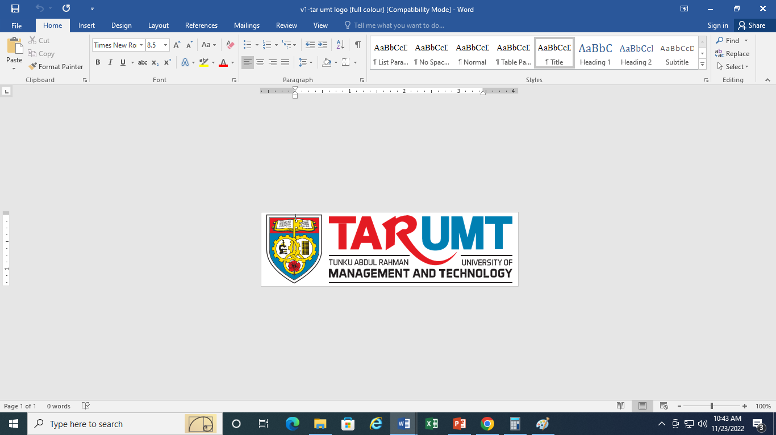
FACULTY OF COMPUTING AND INFORMATION TECHNOLOGY
Programme: R______ (Group: _______)
Assignment
BACS2163 SOFTWARE ENGINEERING
Name(Block Letters) | Registration No. | Signature | Marks
1.
2.
3.
4.
5.

Tutor’s Name: _____________________
Date of Submission: ________________

FORM 2
FACULTY OF COMPUTING AND INFORMATION TECHNOLOGY
Plagiarism Statement and Guideline for Late Submission of Coursework Read, complete, and sign this statement to be submitted with the written report. We confirm that the submitted works are all our own work and are in our own words.
Name(Block Letters) | Registration No. | Signature | Date
1.
2.
3.
4.
5.

Page 5 of 5

